**Module 1 (SDLC)**

1. What is software? What is software engineering?

* Software is a set of programs that allow the user to perform a well-defined function or some specified task.
* Software engineering is all about developing products, using well-defined scientific principles and methods.

1. Explain types of software?

* System software
* Programming software
* Application software

1. What is SDLC? Explain each phase of SDLC?

* SDLC Is System Development life cycle.
* Planning:- (Programming flow)
* Implementation:- (coding)
* Testing:- (debug , csr)
* Documentation:- srs document is used for implementing system.
* Deployment:- Live on store (Play Store, App Store)
* Support & maintenance:- maintenance of product

1. What is DFD? Create DFD Diagram on Flipkart

* DFD is Data flow diagram

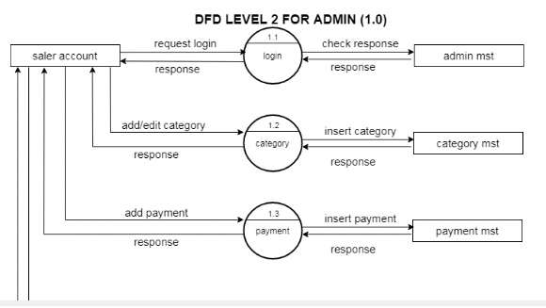

1. What is flow chart? create a flowchart to make addition of two numbers

* Flowchart is graphical representation of a program.

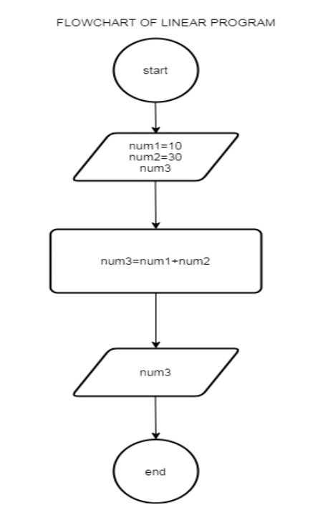

1. What is Use case diagram? Create a use case on bill payment.

